CITI Training Instructions (Updated 8/28/2017)
Step 1: Go to http://www.citiprogram.org/default.asp?language=english.
Step 2: Click on the blue “Register” tab, the home screen image changes frequently and may appear different than the image below.

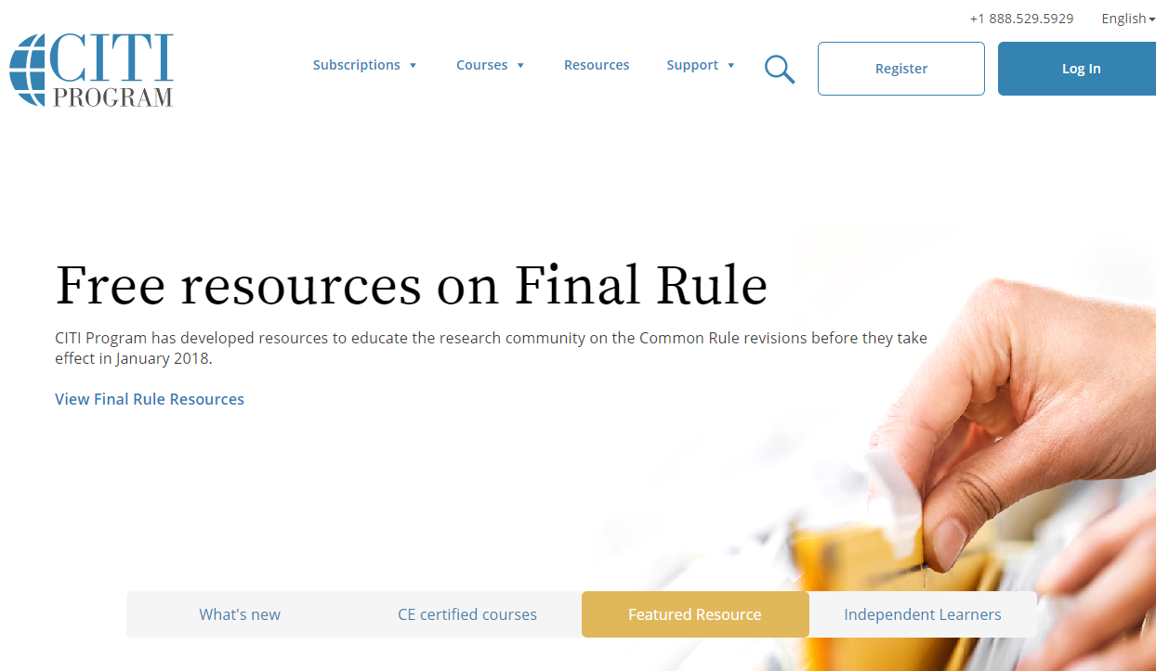
Step 3: Type the name of your institution into, then press “Enter”. Make sure to agree to the terms of service before continuing to Step 2.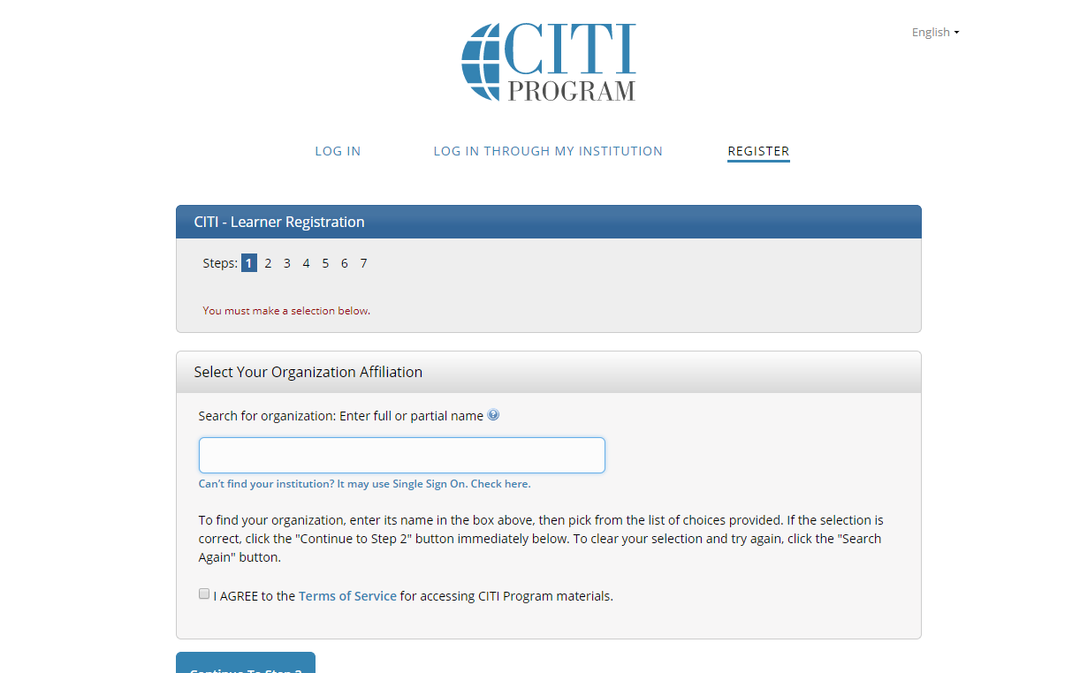
Step 4: Enter name and e-mail address. It is recommended that you enter a secondary e-mail. (CITI will not send you spam.)
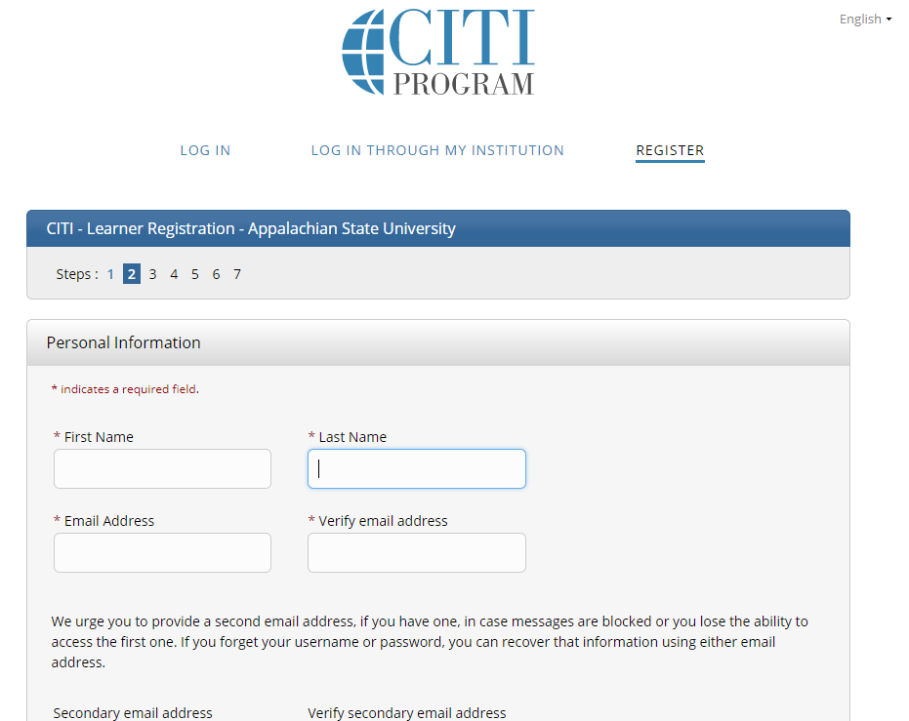
Step 5: Create a username and password. Also, select a security question.
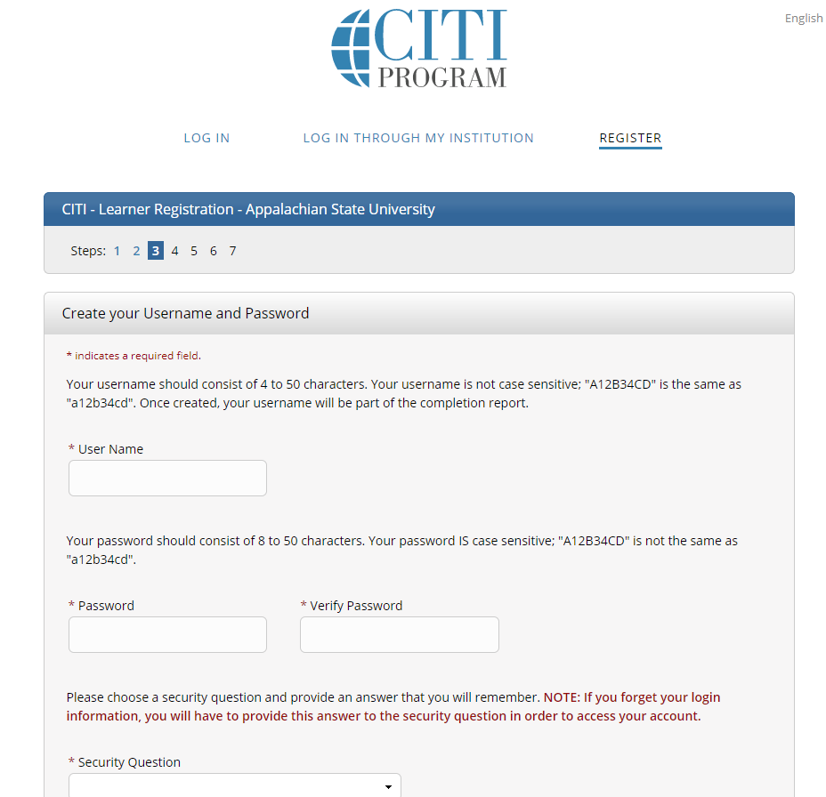

Step 6: Select your country of residence.
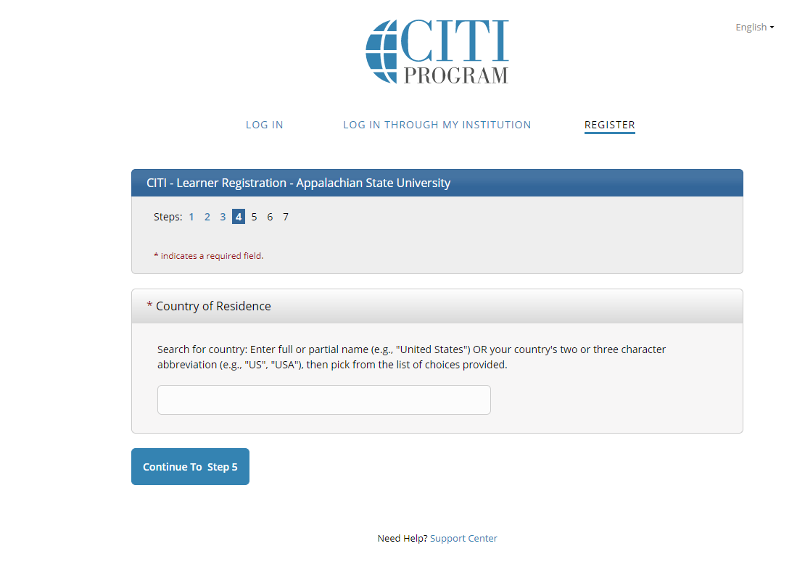

Step 7: Select that you are NOT interested in the option of receiving Continuing Education Credit. (CEC).
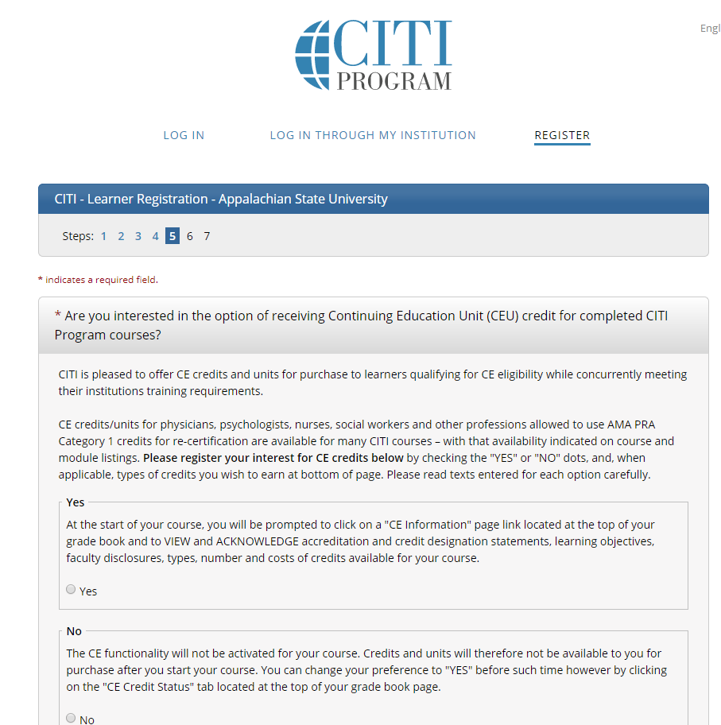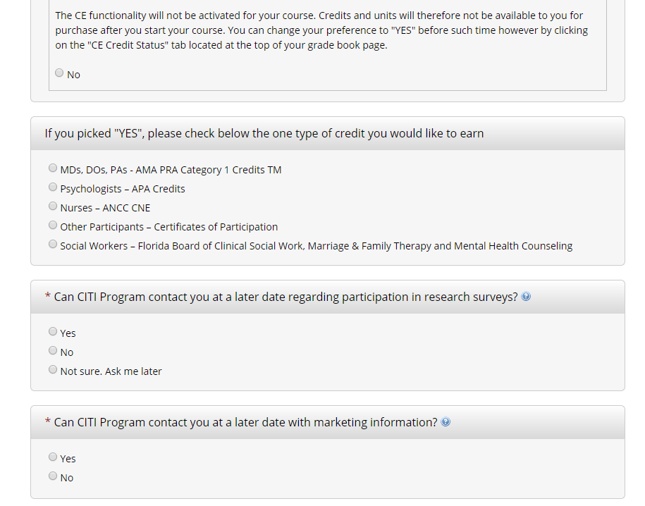
Step 8: Appalachian State University has a certain set of required information; fill in requested information as well as the course you intend to take.
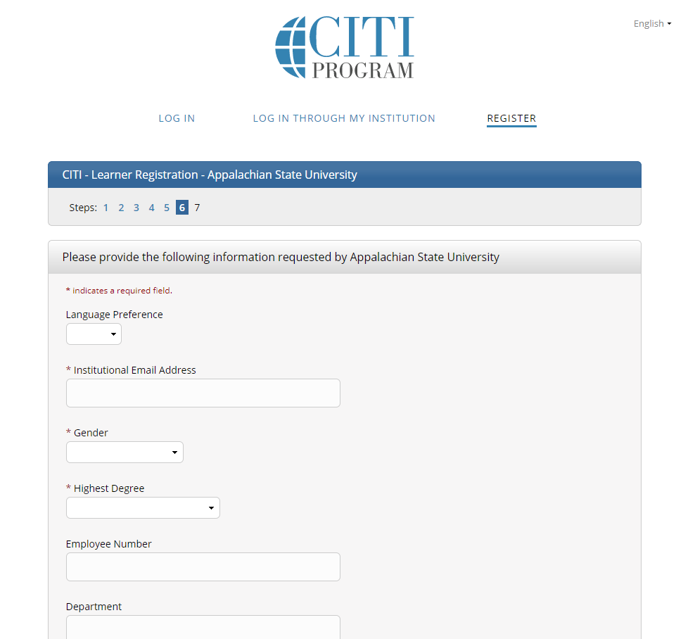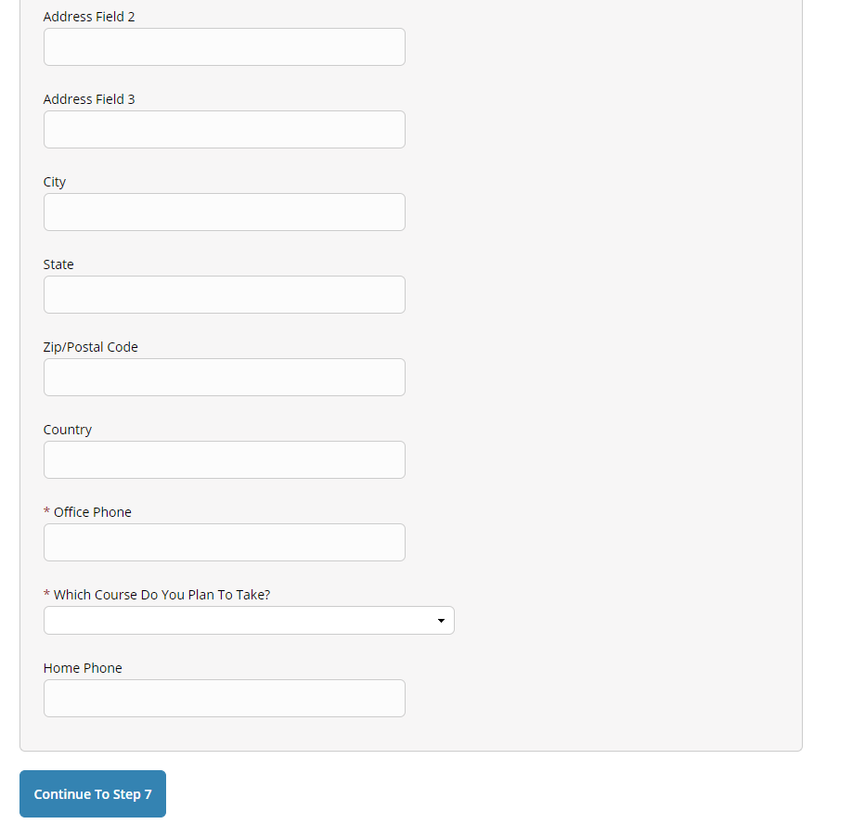
If you are working with human subjects (IRB), select either:
Refresher Course Biomedical or Refresher Course Social and Behavioral
If you are working with animals (IACUC), select:
Laboratory Animal Welfare
If you are working with Biohazardous materials or recombinant DNA, select:
Biosafety/Biosecurity
Then click “Continue to Step 7”.

Step 9: Select the area of research that applies to you. (You can select more than one). Then click “Next”. *This selection will determine the courses available to you.
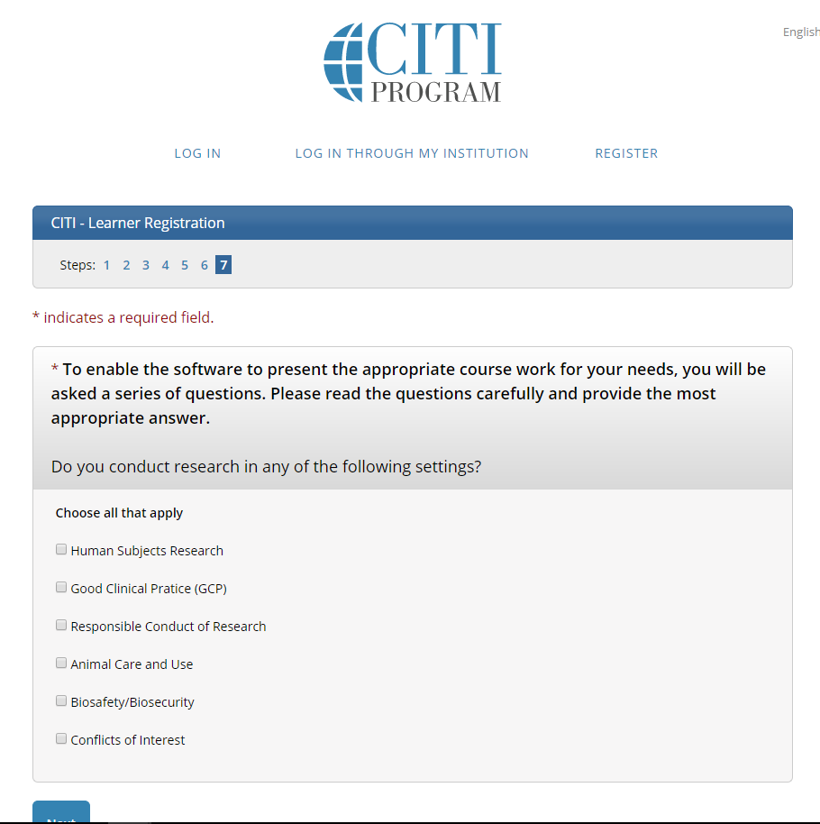
Step 10: Select whether or not you have previously completely the CITI Basic Course in the Protection of Human Research Subjects. If you are taking a refresher course select “Yes”. Then click “Next”.
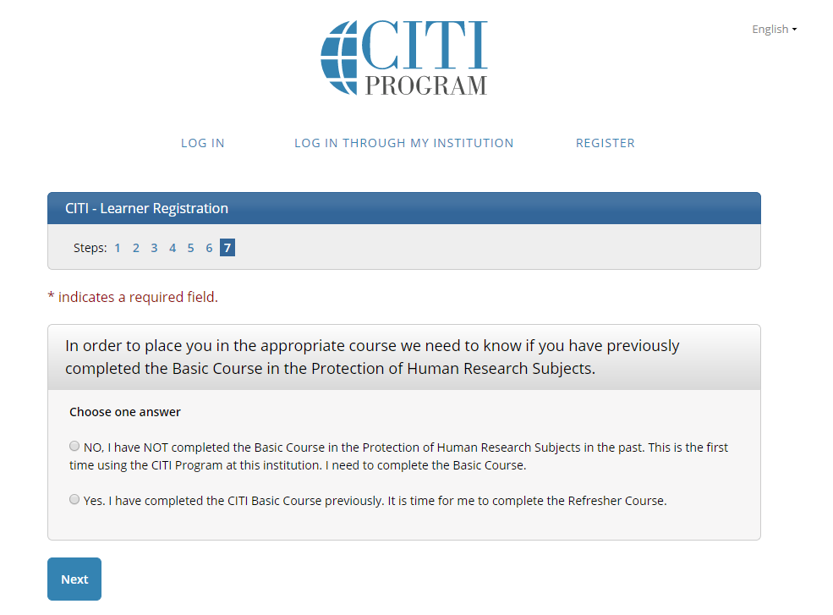
Step 11: If you are signing up for IRB training, you must select either Biomedical or Social & Behavioral Research. The Refresher course takes approximately 2 hours to complete.
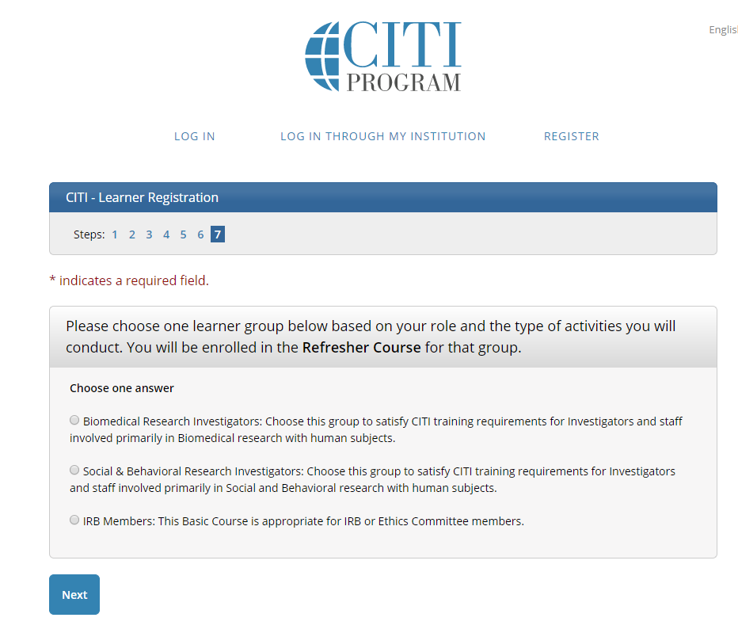
After you have selected all relevant courses, scroll to the bottom of the page and choose “Complete Registration.”
To start a course, click on the course and proceed. You do not need to complete the entire course in one sitting. CITI will record your progress so long as you complete the quiz at the end of a section.
When you complete a course, CITI will send you a Completion Report and copy the Office of Research Protections.

