Disposal of Broken Glassware
- If an injury occurs due to contaminated broken glassware, contact the PI immediately; if the PI is not available, contact the University Police (828-262- 8000) for further instruction. Otherwise, notify the PI immediately and proceed with glassware disposal.

- Glass will cut through gloves! When cleaning broken glass, use mechanical means to pick up the pieces:
  - Tongs, tweezers, or forceps should be used to pick up large pieces
  - Small shards can be picked up using a dust pan and broom

- Disposal
  - Contaminated broken glass
    - For biologically contaminated broken glass, place in a sharps container
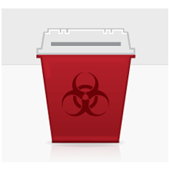

    - For chemically contaminated broken glass, or glass that is contaminated with both biohazards and chemicals, place in a puncture-proof, leak-proof container labeled for chemical waste. Contact EHS&EM (828-262-4008) for disposal instructions.

- Uncontaminated broken glass
  - Uncontaminated broken glass can be disposed of in a glass disposal box
