EPAP Tutorial

Step one: Click on this link: appstate.myresearchonline.org/air/.
Step two: You will be taken to this login screen:

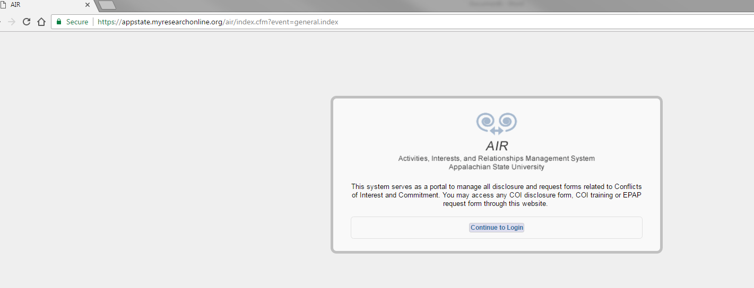
Click continue to Login and put in your Username and Password that you use to log in to Appalnet and your campus email.
Step three: It should take you to the home page of AIR, which looks like this:

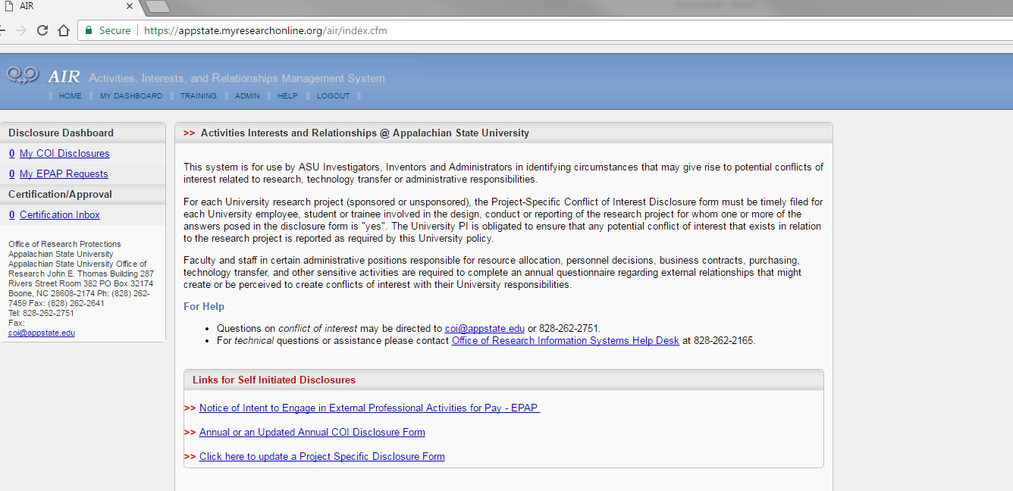
Step 4: Under Links for Self Initiated Disclosures you will want to click on the first hyperlink Notice of Intent to Engage in External Professional Activities for Pay-EPAP

Step 5: When you click on the hyperlink the following will populate, but instead of black marks you will find your own identifying fields completed.
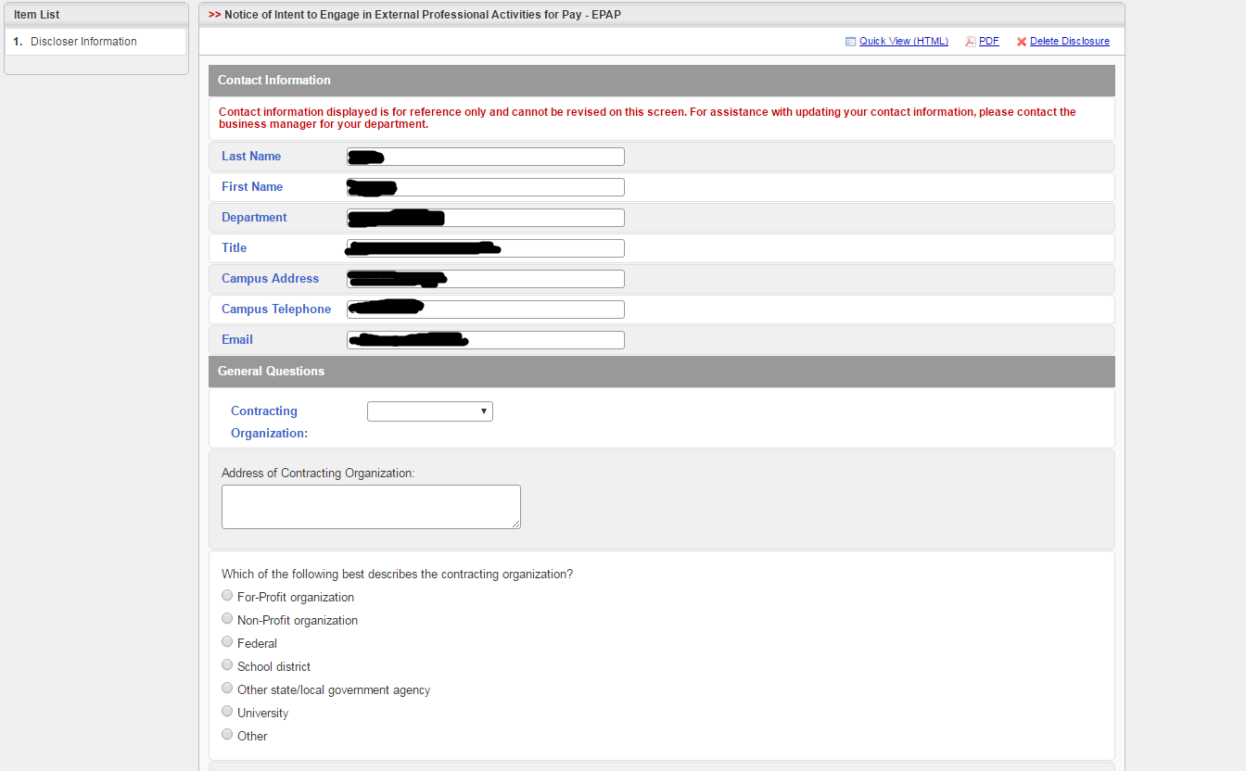
Step 6: When continuing to complete your EPAP, please notice the following toolbar:
Step 6a. You will need to click on the toolbar, and click on the Sponsor Not Listed option. Which will populate the following screen:
***If there is a glitch with this toolbar (and nothing populates), scroll down to the very bottom of this tutorial to get a helpful tip***
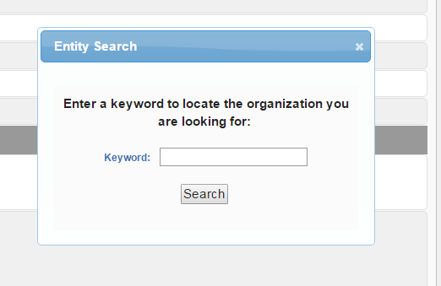
Step 6b: You may type something in OR (recommended) just click enter to get a list of Sponsors/Organizations, as seen below:
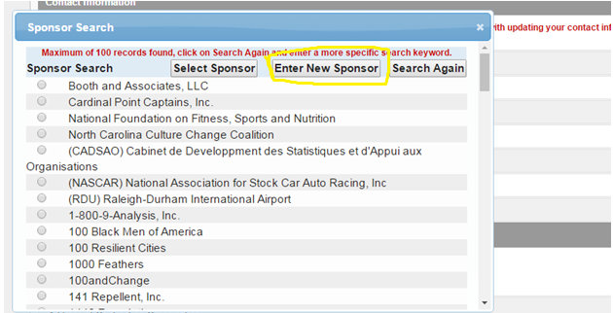
Step 6c: If you scroll down you may find your Sponsor or Organization, if not, click on the Enter New Sponsor tab (squared in yellow) at the top of this Sponsor Search and type in your Sponsor/Organization to add it to the list.

Step 7: You can now continue to complete the questions as they pertain to your situation and press Save and Continue to complete this page.
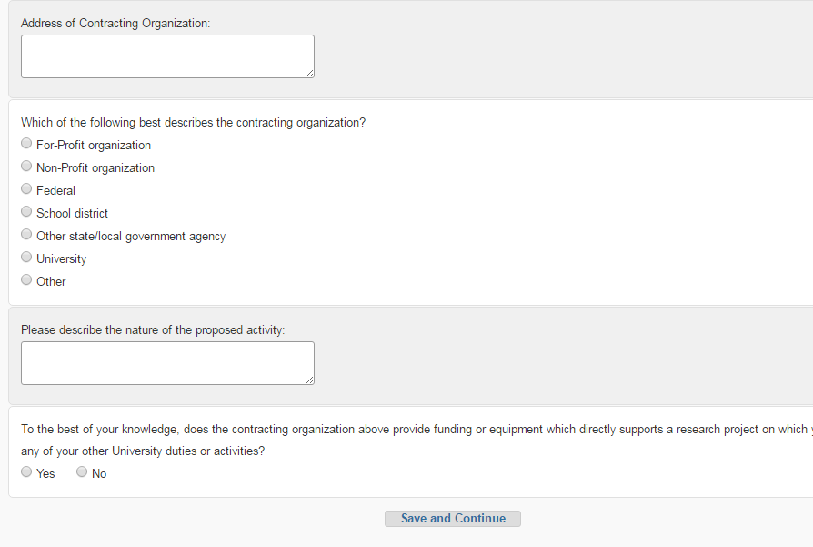

Step 8: Please continue to complete the questions and fields on the following page:
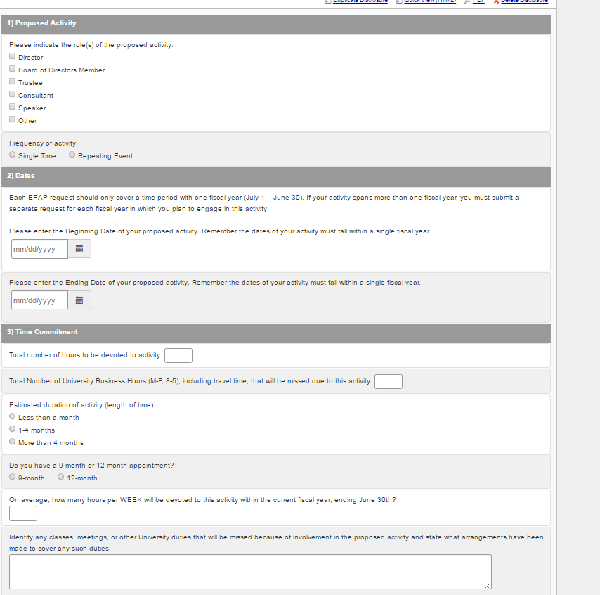
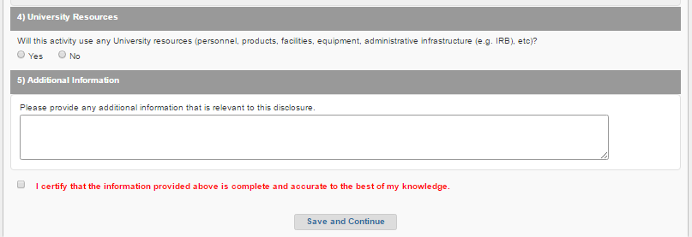
Step 9: Finalize your EPAP form by clicking the check box to the left of the red text. This certifies your form and provides an online signature from you, and lastly press Save and Continue. NOTE: Before you check the box and submit, be sure that all the information you provided is complete and accurate to the best of your knowledge.
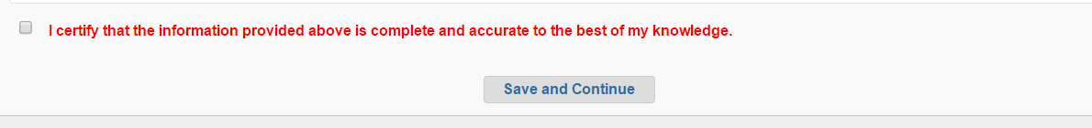

Where does your submission go?
It goes to either to your Department Chair or Dean depending on your classification/rank.

***IF ENCOUNTERING A KNOWN GLITCH WITH THE TOOLBAR***

Sometimes you will encounter a glitch with the search tool. When you click on Sponsor Not Listed it will not populate a keyword search box. This is a common glitch which can be easily fixed by refreshing your webpage.
