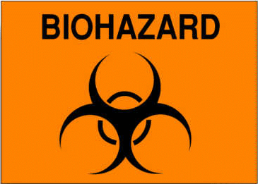

ALL REQUIRED PERSONAL PROTECTIVE EQUIPMENT SHALL BE USED AND REMOVED BEFORE LEAVING THIS AREA

EATING, DRINKING, SMOKING, APPLYING COSMETICS OR LIP BALM, AND HANDLING CONTACT LENSES ARE PROHIBITED IN THIS WORK AREA

NAME OF INFECTIOUS AGENT(S):

TRANSMISSION ROUTE(S):

SPECIAL REQUIREMENTS FOR ENTERING THIS AREA:

EMERGENCY CONTACTS:

PERSONAL PROTECTIVE EQUIPMENT REQUIRED:

IN CASE OF EMERGENCY Date:
CALL UNIVERSITY POLICE: (828) 262-8000 Principal Investigator:
Dial 8000 from any campus phone PI Phone:

