ASULearn access to IACUC community
- Sign into the IACUC community on ASULearn (https://asulearn-projects.appstate.edu/course/view.php?id=178) using your AppState login information. This is the page that will appear after you sign in.

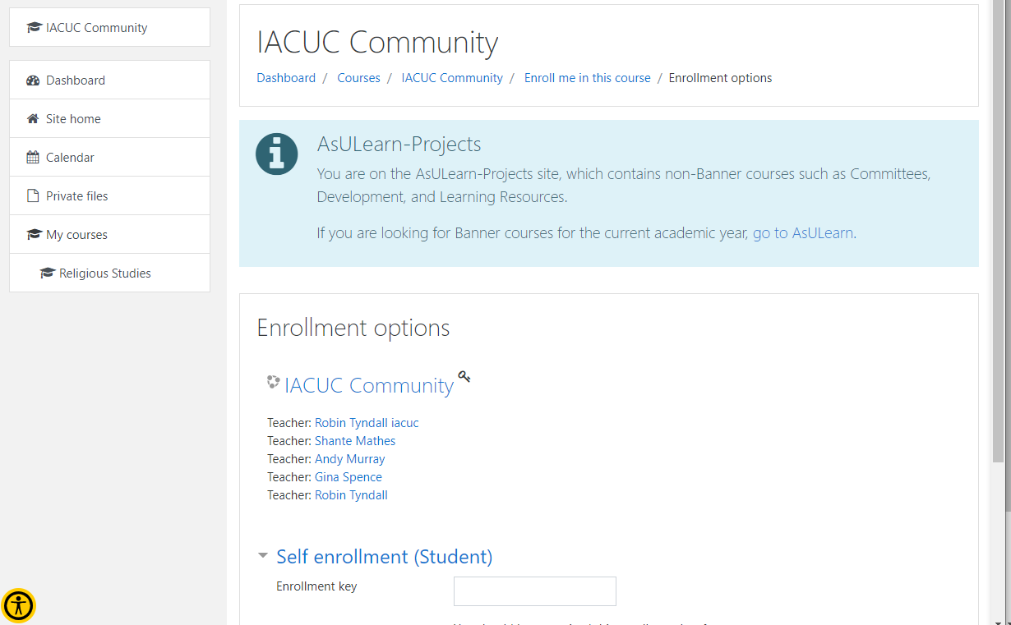

- Once on this page, look for “Self enrollment (Student)”; Enter the single use enrollment key given to you by a PI or the IACUC administrator and click “Enroll Me”.

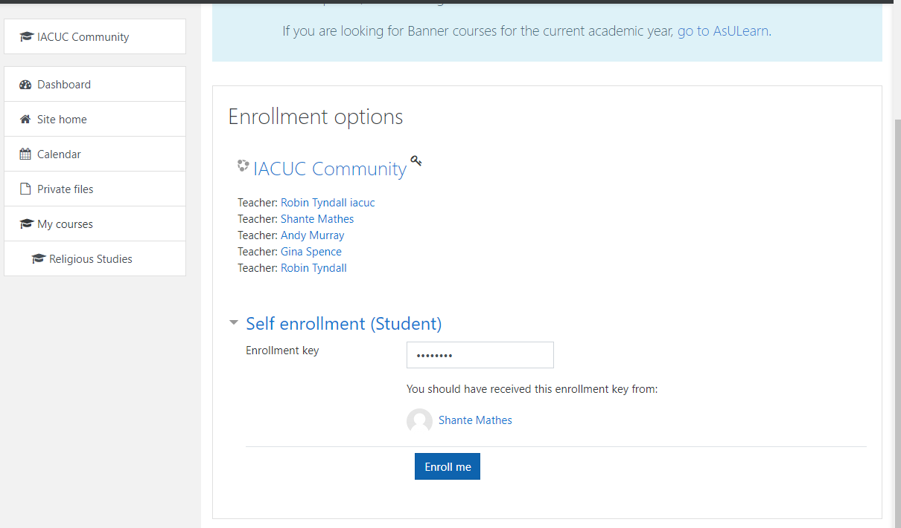

- Welcome to the IACUC community page! Scroll until you see “Species Specific Training” in the left column. Look for your species-specific training and click on it to begin the module. Once complete, click “submit”.

