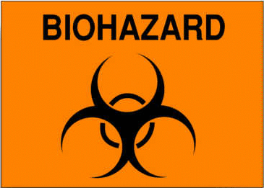ALL REQUIRED PERSONAL PROTECTIVE EQUIPMENT SHALL BE USED AND REMOVED BEFORE LEAVING THIS AREA

EATING, DRINKING, SMOKING, APPLYING COSMETICS OR LIP BALM, AND HANDLING CONTACT LENSES ARE PROHIBITED IN THIS WORK AREA

NAME OF INFECTIOUS AGENT(S):

TRANSMISSION ROUTE(S):

SPECIAL REQUIREMENTS FOR ENTERING THIS AREA:

EMERGENCY CONTACTS:

*Biosafety Level 2 is similar to BL-1 and is suitable for work involving agents of moderate potential hazard to personnel and the environment. It differs from BL-1 in that:
- Lab personnel have specific, documented training in handling pathogenic agents and are being directed to competent scientists;
- Access to the lab is limited when work is being conducted;
- Extreme precautions are taken with contaminated sharp items, and
- Certain procedures in which infectious aerosols or splashes may be created are conducted in biological safety cabinets or other physical containment equipment;
- All biohazardous waste must be handled according to the biohazard waste disposal procedure.

Date:
Principle Investigator:
PI Phone:

